**Devansh Patel - 991574941**

**Jashan Goyal - 991544005**

**Dhruv Rajpara - 991575895**

**Anee Patel -991548757**

**SYST36367 Capstone Project Requirements & Design- Team Sprinters**

**Niagara On the Lake (NOTL) Hydro**

Project Proposal: 2

**Client Profile:** 2

**Team Profile:** 2

**Existing System Description** 3

**System Feasibility & Risks** 4

**User Stories:** 4

Project Plan 5

**Use Case Diagram.** 5

**Domain Class Diagram.** 6

**LOW-RES Wireframe StoryBoard – Sunny day paths only** 7

**Project Environment setup:** 17

**Coding Style Standards:** 17

**Testing Plan / Quality Assurance Plan:** 18

Sprint 1: 19

**Use Case Description:** 19

**Boundary Cases (Rainy Day Paths) Descriptions:** 19

**Use Case Narrative with Low-Res Wireframes (Including rainy-day paths):** 20

**Sprint 2** 26

**Use Case Description:** 26

**Boundary Cases (Rainy Day Paths) Descriptions:** 26

**Use Case Narrative with Low-Res Wireframes (Including rainy-day paths):** 27

Sprint 3: 34

**Use Case Description:** 34

**Boundary Cases (Rainy Day Paths) Descriptions:** 34

**Model Class Diagram:** 35

**Use Case Narrative with Low-Res Wireframes (Including rainy-day paths):** 36

Sprint 4: 53

**Use Case Description:** 53

**Model Class Diagram:** 54

**Use Case Narrative with Low-Res Wireframes:** 59

**Quality Assurance Testing:** 61

Sprint 5: 68

**Use Case Description:** 68

**Model Class Diagram:** 69

**Use Case Narrative with Low-Res Wireframes:** 72

**Project Proposal:**

## **Client Profile:**

* Niagara on the Lake Hydro Inc. is the municipality of Niagara-on-the-electric Lake's utility, serving around 10,000 consumers. In its efforts to minimise greenhouse gas emissions and slow the effects of climate change, the corporation aspires to be an industry leader. Niagara on the Lake Hydro is actively taking steps to minimise its own internal operating emissions, and now wants to help its customers measure, analyse, compare, and ultimately reduce their aggregate carbon footprints.

## **Team Profile:**

* We are team **Sprinters,** currently enrolled in the Computer Systems Technology - Systems Analyst course, and we understand operating and developing web applications using various latest technologies and the best part about our team is we believe in evolve with new technologies. To conclude, our team Sprinters believe in success.

|  |  |  |
| --- | --- | --- |
| Name | Picture | Role and Responsibilities |
| Devansh Patel | Inserting image... | * Building a Database * Frontend Development * Client communication * GitHub update * Trello update |
| Jashan Goyal |  | * Backend Development * User Interface * GitHub update * Trello update * Technical documentation * Team Meeting Organizer |
| Dhruv Kamleshkumar Rajpara |  | * Building a Database * Backend development * GitHub update * Trello update * Technical documentation |
| Anee Patel |  | * Frontend designing * User Interface * Client communication * GitHub update * Trello update |

## **Existing System Description**

* Currently the client does not have any existing, they are looking for everything to be built from scratch. As a part of their mission, they need a tool which their customers can use to track their CO2 emission and, they can compare their carbon footprints with their old footprints to reduce it.
* The client has gone through some tools, available online, which we can refer to and get a clear understanding of the client requirements and the UI design.
* <https://www.carbonfootprint.com/>
* <https://www.carbonzero.ca/>
* <https://treecanada.ca/>
* <https://app.projectneutral.org/>

## **System Feasibility & Risks**

* The online tool will be made by following the good practices of website development and we will keep in mind the safety of the website from the security perspective.
* Team coordination will be required in order to lead the project to pass with flying colors.
* We as a team will try to understand the requirements and work together so that we can overcome any issue.

## **User Stories:**

* As an administrator, I would like to be able to see if the website is being used or not.
* As an Administrator, I would like to store user details in a database so that I can keep a track of user details.
* As a new customer, I'd like to be able to register on the website.
* As a customer, I would like a website that is user friendly and easy to navigate.
* As a customer, I would like to be able to track my emissions.
* As a customer, I would like to be able to save the data that I enter.
* As a customer, I would like to be able to compare the emissions with my previous emissions.
* As a customer, I would like to be able to track my emissions as per the square feet of the house.
* As a customer, I would like to see my carbon footprints.

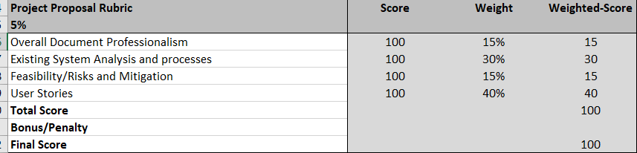

# **Project Plan**

## **Use Case Diagram.**

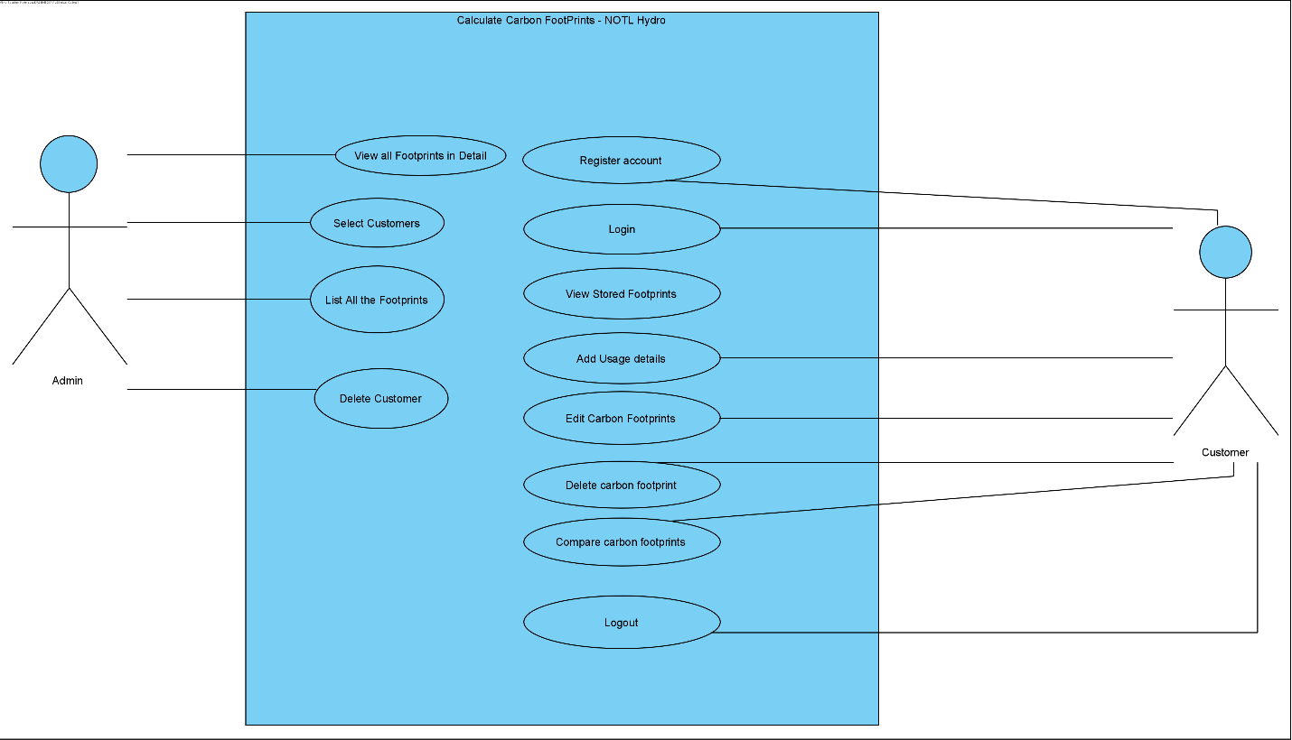

## **Domain Class Diagram.**

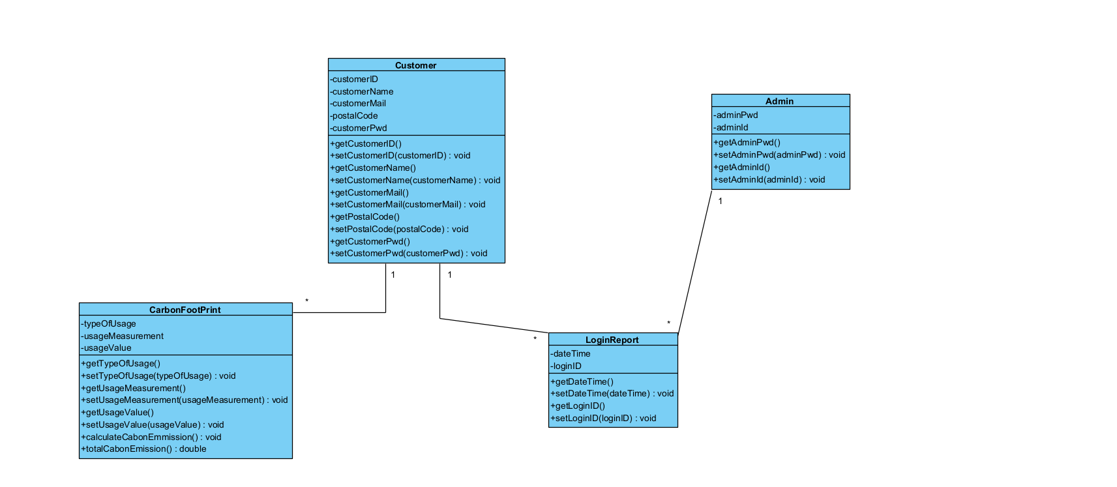

## **LOW-RES Wireframe StoryBoard – Sunny day paths only**

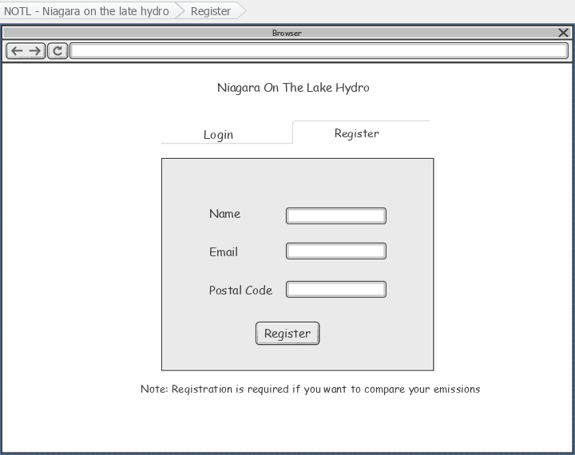

A customer can register using name, email, and postal code if they want to save and compare their carbon footprints over time.

When ‘Register’ button is clicked, a customer can login to calculate and can save their calculations in order to compare their carbon emissions and can take necessary steps to reduce the greenhouse gases.

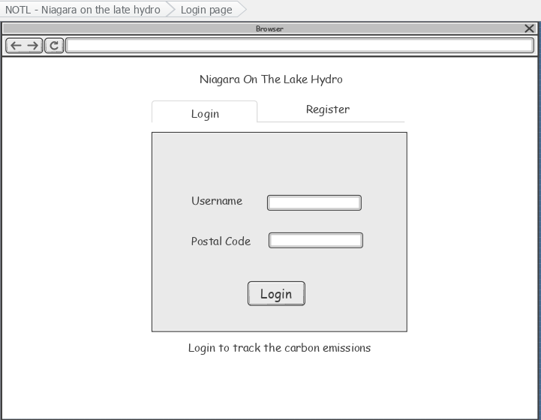

A customer can login using username and postal code and can calculate the carbon footprints.

When ‘Login’ button is clicked, it will redirect to the Calculator page where the customer can enter the required information and can calculate the carbon footprints.

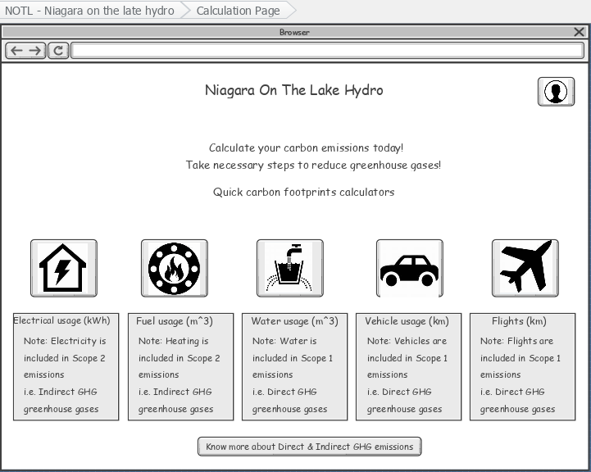

When profile icon is clicked, it will redirect to Login/Register page.

A customer can click on any of these icons to calculate the carbon footprints. When the icon is clicked a pop-up appears that contains the input fields for the calculation.

When this button is clicked, a website opens that has more information about Scope 1, Scope 2, and Scope 3 emissions.

When customer clicks on the Month dropdown, all the months will appear, and the customer can select the month for which they is entering the electrical usage.

When customer clicks on input field, they will be able to enter the usage in kWh.

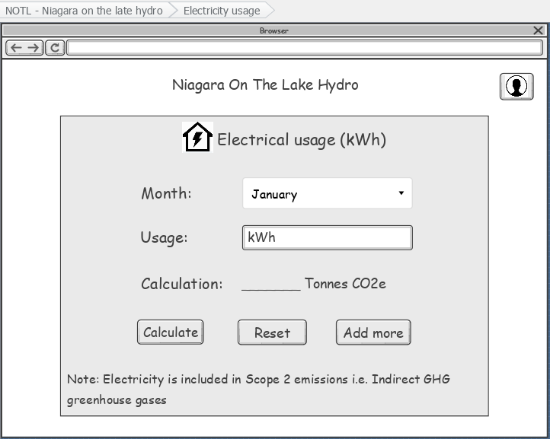

When ‘Add more’ is clicked, history page will open that contains monthly usage calculations.

When ‘Calculate’ button is clicked the calculation result will appear in the above label.

When customer clicks on the Month dropdown, all the months will appear, and the customer can select the month for which they is entering the fuel usage.

Customer can select the option for the fuel type.

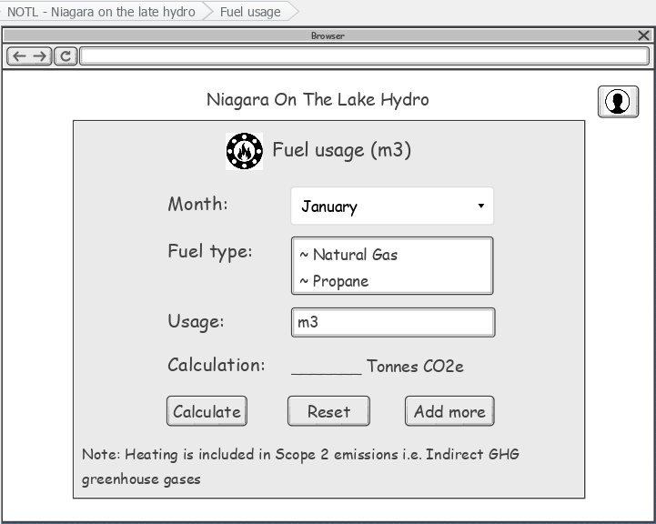

When ‘Add more’ is clicked, history page will open that contains monthly usage calculations.

When ‘Calculate’ button is clicked the calculation result will appear in the above label.

When customer clicks on the Month dropdown, all the months will appear, and the customer can select the month for which they is entering the water usage.

When customer clicks on input field, they will be able to enter the usage in m3.

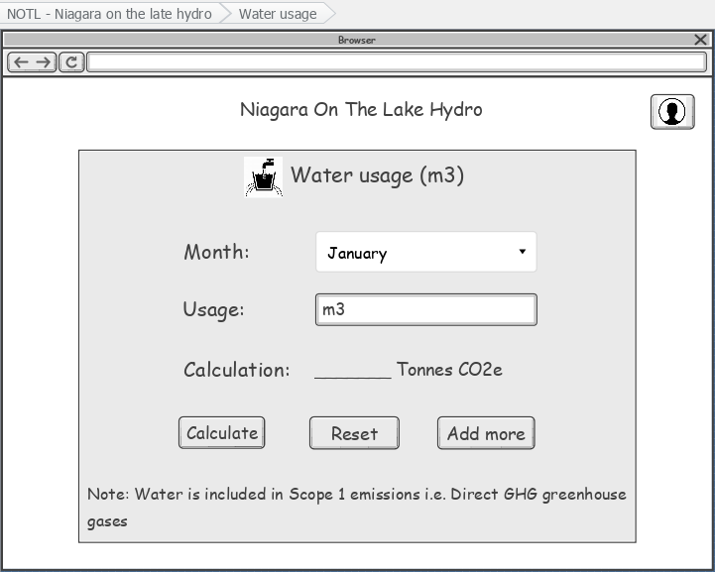

When ‘Add more’ is clicked, history page will open that contains monthly usage calculations.

When ‘Calculate’ button is clicked the calculation result will appear in the above label.

When customer clicks on the Month dropdown, all the months will appear, and the customer can select the month for which they is entering the vehicle usage.

Customer can select the option for the fuel type.

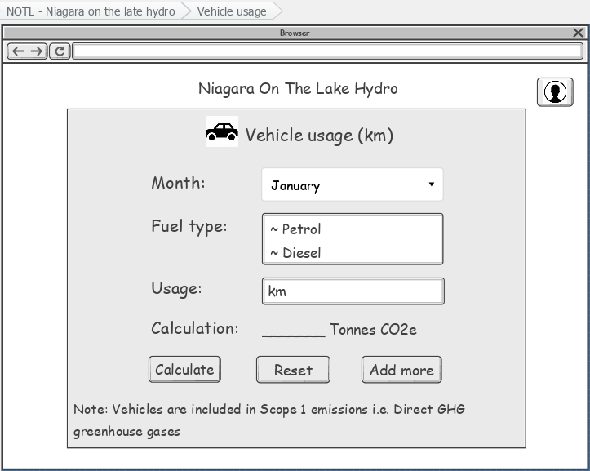

When ‘Calculate’ button is clicked the calculation result will appear in the above label.

When ‘Add more’ is clicked, history page will open that contains monthly usage calculations.

When customer clicks on the Month dropdown, all the months will appear, and the customer can select the month for which they is entering the flights usage.

Customer can select the option for the type of trip.

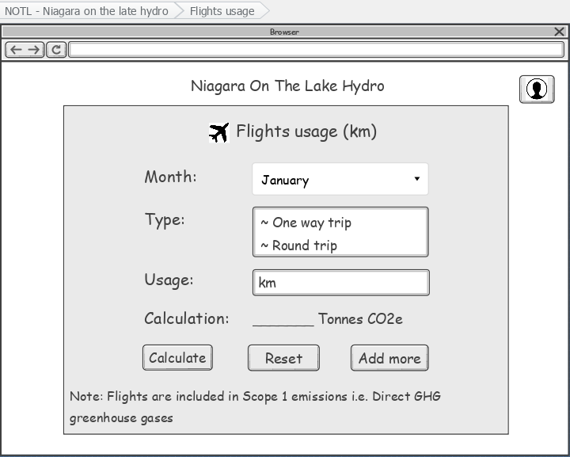

When ‘Add more’ is clicked, history page will open that contains monthly usage calculations.

When ‘Calculate’ button is clicked the calculation result will appear in the above label.

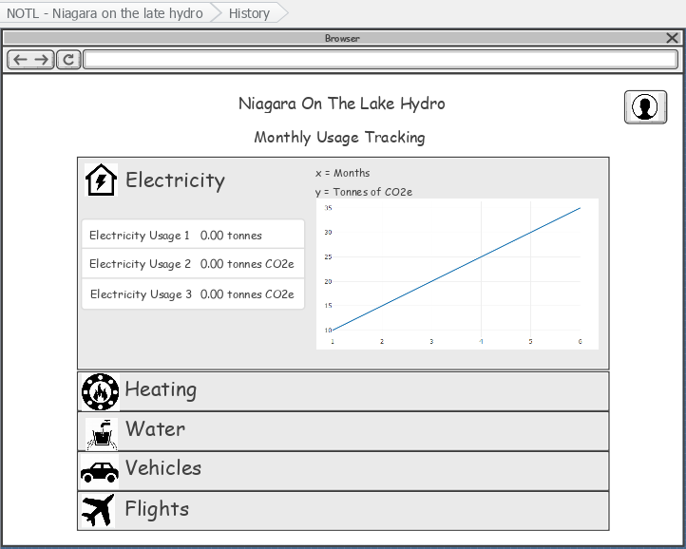

When customer clicks on the list items, it will expand to show the calculations as per months. A line graph also appears to show the carbon footprints monthly so that the customers can compare their carbon emissions.

## **Project Environment setup:**

* **GitHub link**: <https://github.com/rajparad/NOTLProject>
* **Server Link:** [**https://sprinters.azurewebsites.net/**](https://sprinters.azurewebsites.net/)
* **Language:** Asp .Net with Angular for frontend
* **Docker:** Optional, maybe added in the later stages of the project
* **Framework:** .NET Core Framework
* Hello World application is running at the server address. Here is the screenshot of the working server
* **Hello World Working Link:** [**https://sprinters.azurewebsites.net/**](https://sprinters.azurewebsites.net/)

## **Coding Style Standards:**

In Application Development Coding style is very important. All the large corporations follow coding styles and naming conventions. If there is pre-set code styling plan then it makes the developer’s life a little easy and additionally is easy to read, maintain and debug the application in later stages of the project development.

For our project (C# Language):

1. **Pascal case:** will be using “PascalCasing” when naming classes or struct.
2. **Naming Interface:** Will add the prefix ‘I’ in addition to the Interface name. **For example,** for a student entity-based interface, we will name it as **IStudent.**
3. **Camel Case:** When naming class fields, we will make use of “camelCasing” and in the constructors or methods if we are having any conflicts naming any method parameter then we will add **_** (underscore) in front of the class field.

* For Example, if there is a local variable named **newinfo** in our application then we will use it as **newInfo,**
* if we are using **newinfo** variable globally then we will use it **NewInfo**.
* if there is any Enum for **newinfo** then for that we will use **NEWINFO**.

1. We will be using default layout conventions in the Code Editor and will be taking care of proper indentation.
2. **Proper Formatting:** We will be using proper formatting when finished writing the small parts of the code so that at the end of the project we do not get a hard time in compiling when using Auto-formatting.
3. Writing the comment in the new line and end it with a period.
4. On creation of file, proper commenting will be done indicating the purpose of the file or class so that the code reviewers get the scope of the code.
5. For naming convention, we will stick with the camel case type for local variable creation
6. We will also put spaces and commas to improve indentation.

* To declare a **variable p** which has **value read** we will use space before and after initializer e.g., **p = “read”.**

1. For naming methods,

* Method that is getting data for that we will use **getData**.
* Method that is updating some data for that we will use **updateData.**

1. We will use the **best practices** to make our code well organized and documented to the best of our knowledge.

## **Testing Plan / Quality Assurance Plan:**

A tested application with proper use cases always performs well.

For our project:

1. We will plan all the tests that suit our application and make sure that each task has some logic to test rainy day paths.
2. We are also planning to use Test Driven Development for this.
3. In test creation we will use quality attributes which are necessary to make test easy and smooth such **as Functionality, Usability, Maintainability, Reliability** etc.
4. We will make use of Unit Testing to check if our code has any issues.
5. We will use techniques like Black Box testing, white box testing to check I/O and behavior of our application.

**Rubric:**

|  |  |  |  |
| --- | --- | --- | --- |
| **Project Plan Rubric - 10%** | **Score** | **Weight** | **Weighted-Score** |
| Overall Document Professionalism | 100 | 0.2 | 20 |
| Use Cases/wireframe storyboards | 100 | 0.1 | 10 |
| Wireframe Storyboards | 100 | 0.3 | 30 |
| Domain Class Diagram | 100 | 0.1 | 10 |
| Coding Style Standards/ QAP Testing Plan | 100 | 0.2 | 20 |
| Project Environment / Hello World | 100 | 0.1 | 10 |
| **Total Score** |  |  | 100 |

# **Sprint 1:**

## **Use Case Description:**

* ‘RegisterAccount’ use case is for registering the customers to the website to save their data.
* A customer can track their carbon emissions based on their electrical, water, different types of fuel usage monthly. So, if the customer wishes to save the data and come back to compare the emissions per month, then the customer needs to register/create account on the website.
* Also, the ‘RegisterAccount’ use case is related to ‘Login’ use case as the customer will be able to login after registering the account.

## **Boundary Cases (Rainy Day Paths) Descriptions:**

In Register use case, the rainy-day paths to consider are:

* Name is required
* Name should be atleast 3 characters long
* Username already taken
* Email Address is required
* Please enter valid Email Address
* Postal Code is required
* Please enter correct Postal Code (Ex. A1A 1A1)

## **Use Case Narrative with Low-Res Wireframes (Including rainy-day paths):**

RegisterAccount – Sunny Day path:

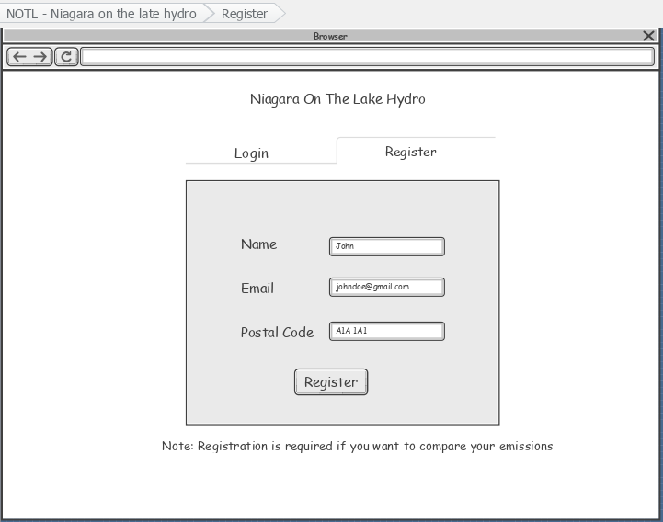

A customer can register using name, email, and postal code if they want to save and compare their carbon footprints over time.

When ‘Register’ button is clicked, a pop up will appear displaying ‘Registration successful’ message and a customer will be redirected to a login page to login.

Registration Successful.

New user created!

RegisterAccount – Rainy Day path:

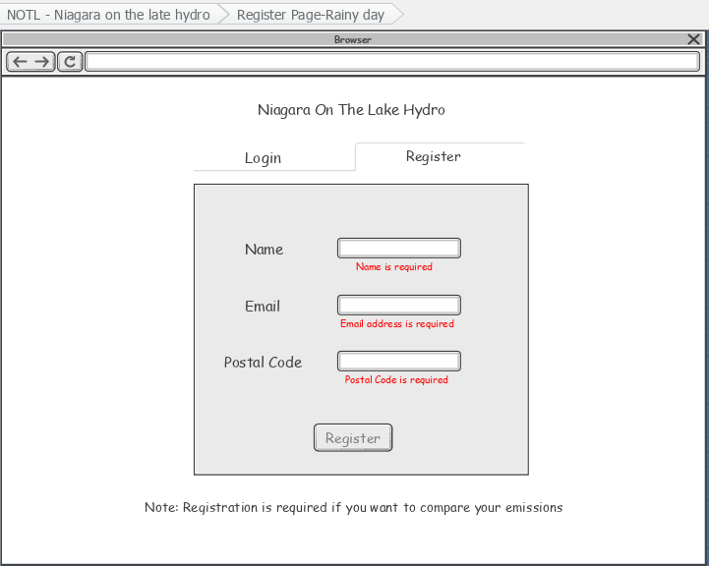

When a customer fails to fill in the input fields, the ‘Register’ button will be disabled, and error messages will be displayed until the customer fills in all the input fields.

RegisterAccount – Rainy Day path:

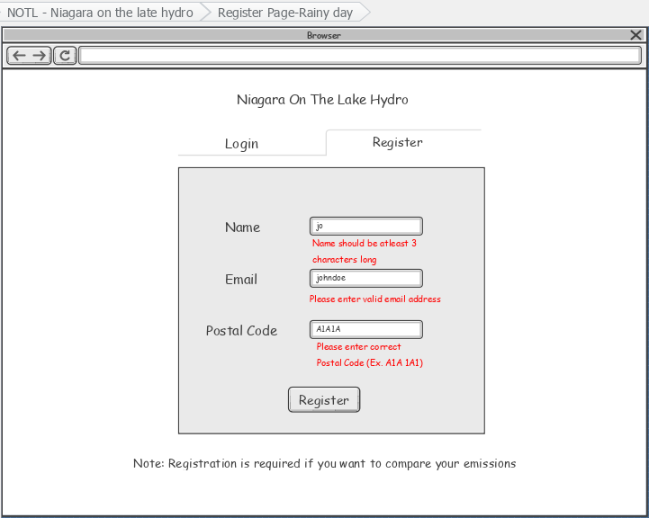

Registration failed.

Username is already taken.

When a customer enters a username that is already taken. It will show a pop-up message that the registration is failed.

When a customer enters postal code in wrong format, an error message will appear.

When a customer enters incorrect Email, an error message will appear.

When a customer enters only 2 characters in Name field, an error message will appear.

**Quality Assurance Notes for Sprint**

Following unit tests are considered in this use case’s test suite to test one unit of code:

* TestCheckInputsGood(): A test method to return the good inputs for name, email and postal code. Ex. “John”, “johndoe@gmail.com”, “A1A 1A1” respectively.
* TestCheckNameException(): A test method to return the bad input exception for name because name cannot be less than 3 characters. Ex. “Jo”.
* TestCheckEmailException(): A test method to return the bad input exception for email because email must be in correct format. Ex. “johndoe”.
* TestCheckPostalCodeLength(): A test method to return the bad input exception for postal code because postal code must be in correct format. Ex. “A1A1A”.

UnitTest document:

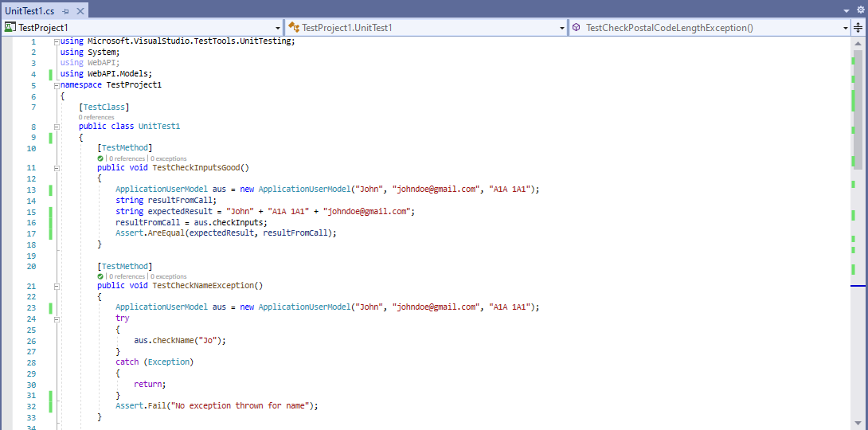

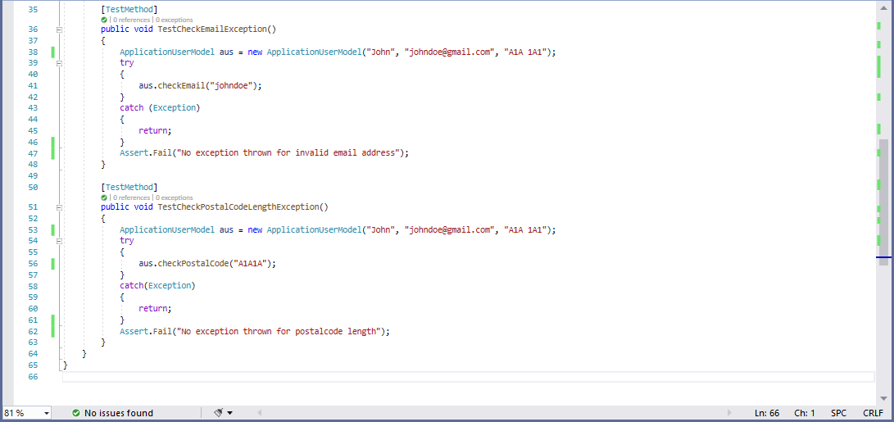

UnitTest results:

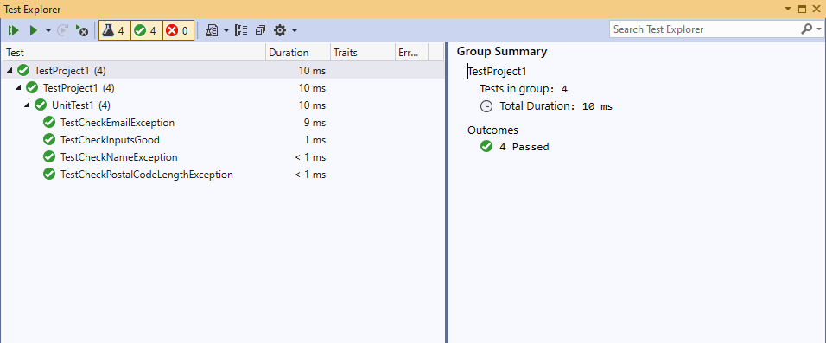

**Presentation**



## **Sprint 2**

## **Use Case Description:**

* ‘Login’ use case is for logging into the website to let the customers see their data.
* A customer can see their carbon emissions data and compare it monthly based on their electrical, water, different types of fuel usage. So, if the customer wishes to see the data and come back to compare the emissions per month, then the customer needs to login to the website.
* Also, the ‘Login’ use case is related to ‘RegisterAccount’ use case as the customer will be able to login after registering the account.

## **Boundary Cases (Rainy Day Paths) Descriptions:**

In Register use case, the rainy-day paths to consider are:

* Username is required
* Username should be at least 3 characters long
* Username should not be more than 20 characters long
* Postal Code is required
* Please enter correct Postal Code (Ex. A1A 1A1)
* Incorrect Username
* Incorrect Postal Code

## **Use Case Narrative with Low-Res Wireframes (Including rainy-day paths):**

Login – Sunny Day path:



A customer can login using username and postal code and can calculate the carbon footprints.

When ‘Login’ button is clicked, it will redirect to the Calculator page where the customer can enter the required information and can calculate the carbon footprints.

Login Successful!

Login – Rainy Day path:

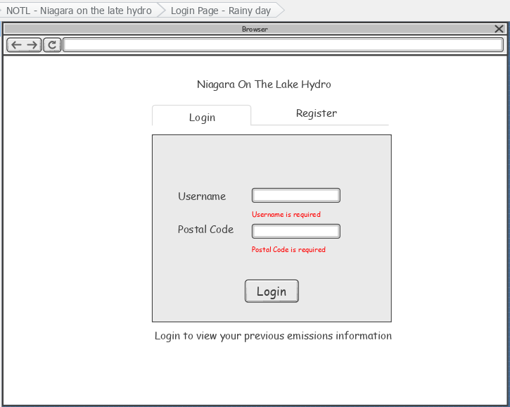

When a customer fails to fill in the input fields, the ‘Login’ button will be disabled, and error messages will be displayed until the customer fills in all the input fields.

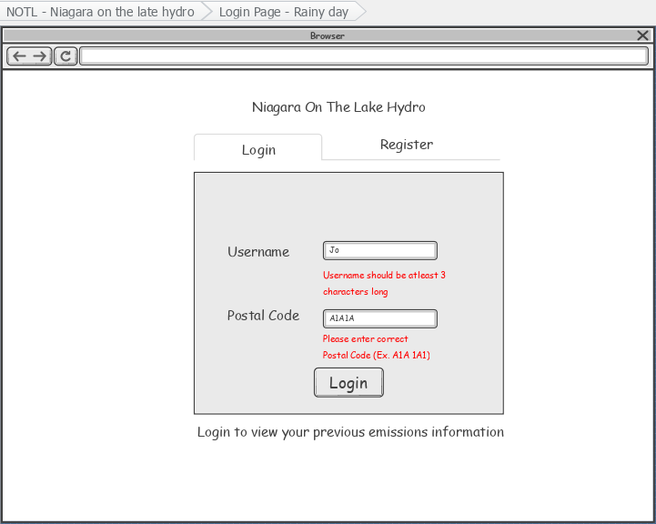

**Authentication failed.**

Incorrect username or postal code

When a customer enters a username or a postal code that doesn’t match the registration details. It will show a pop-up message that the username or postal code is incorrect.

When a customer enters postal code in wrong format, an error message will appear.

When a customer enters only 2 characters in username field, an error message will appear.

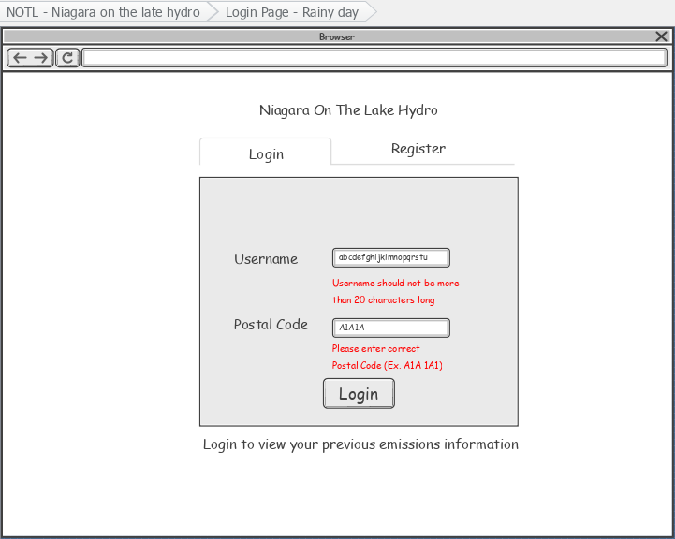

When a customer enters more than 20 characters in username field, an error message will appear.

**Quality Assurance Notes for Sprint**

Following unit tests are considered in this use case’s test suite to test one unit of code:

* TestCheckInputsGood(): A test method to return the good inputs for name, email and postal code. Ex. “John”, “johndoe@gmail.com”, “A1A 1A1” respectively.
* TestCheckUserNameMinlengthException(): A test method to return the bad input exception for name because name cannot be less than 3 characters. Ex. “Jo”.
* TestCheckUserNameMaxlengthException(): A test method to return the bad input exception for name because name cannot be more than 20 characters. Ex. “abcdefghijklmnopqrstu”.
* TestCheckPostalCodeLength(): A test method to return the bad input exception for postal code because postal code must be in correct format. Ex. “A1A1A”.

UnitTest document:

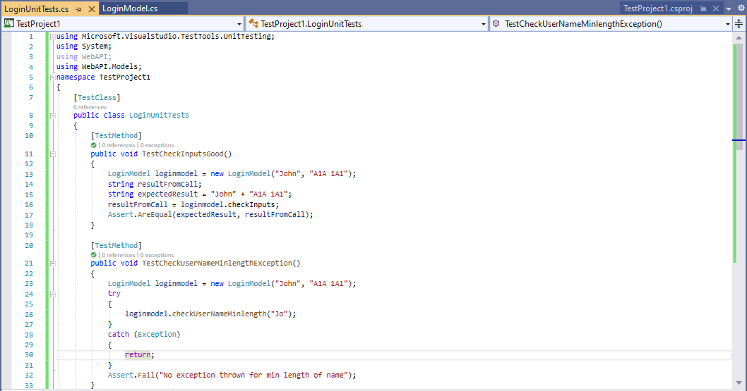

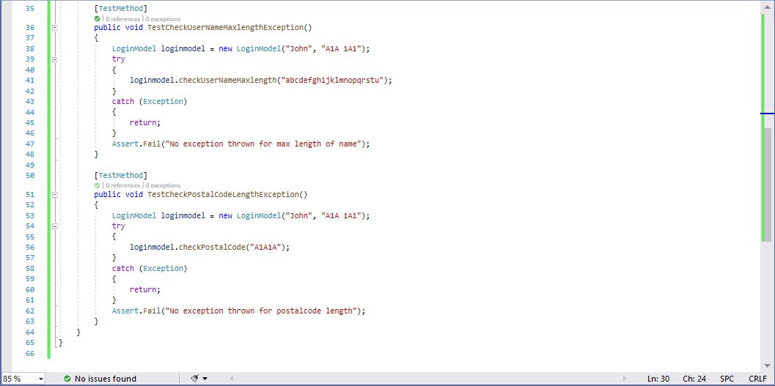

UnitTest results:

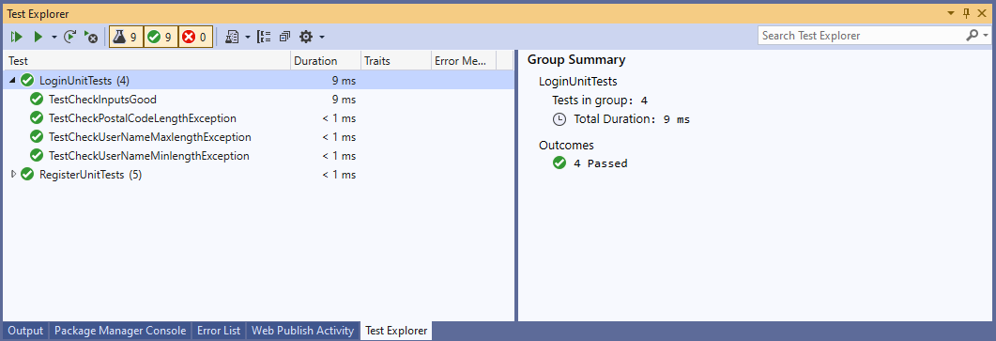

# **Sprint 3:**

## **Use Case Description:**

* ‘CalculateCarbonfootprints’ use case is for allowing the customers to calculate their carbon footprints based on different usages.
* A customer can track their carbon emissions based on their electrical, water, different types of fuel usage monthly.

## **Boundary Cases (Rainy Day Paths) Descriptions:**

In CalculateCarbonfootprints use case, the rainy-day paths to consider are:

* Incorrect usage:
* When customer does not input data in the usage field.
* When customer enters a very long value of usage.
* When customer enters a negative value.
* When customer enters any character or letters instead of numbers.

## **Model Class Diagram:**

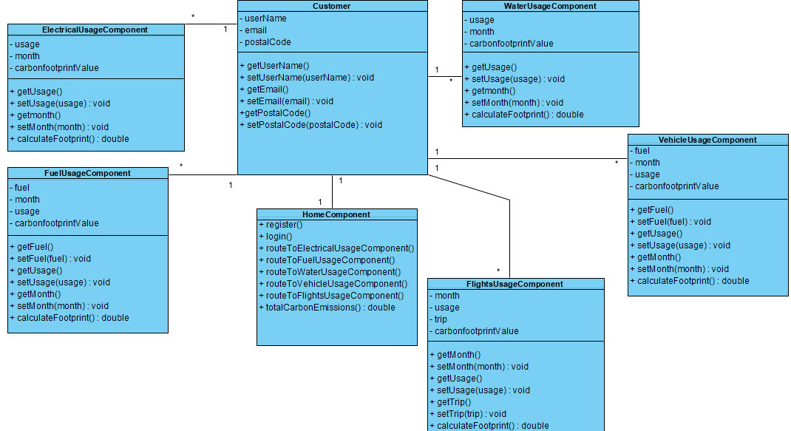

## **Use Case Narrative with Low-Res Wireframes (Including rainy-day paths):**

Home Page

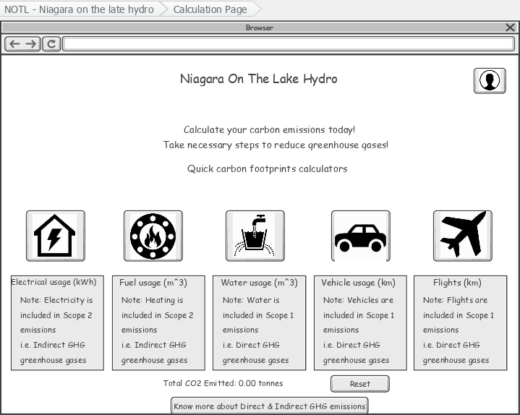

When profile icon is clicked, it will redirect to Login/Register page.

Total CO2 emitted will appear here

A customer can click on any of these icons to calculate the carbon footprints. When the icon is clicked a new page appears that contains the input fields for the calculation.

This button will reset the total

When this button is clicked, a website opens that has more information about Scope 1, Scope 2, and Scope 3 emissions.

CalculateCarbonfootprints – Electrical Usage – Sunny Day path:

When customer clicks on the Month dropdown, all the months will appear, and the customer can select the month for which they are entering the electrical usage.

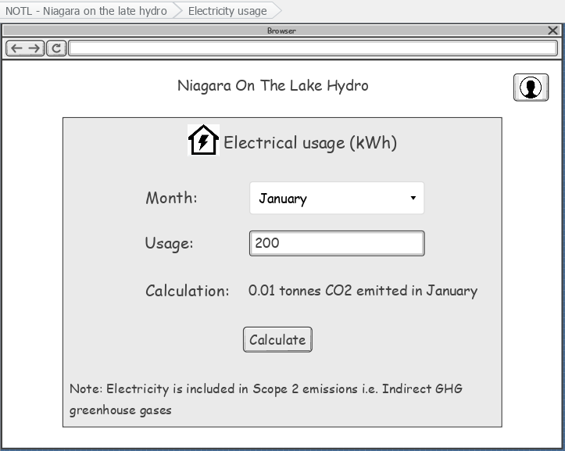

When ‘Calculate’ button is clicked the calculation result will appear in the above label.

When customer clicks on input field, they will be able to enter the usage in kWh.

CalculateCarbonfootprints – Electrical Usage – Rainy Day path:

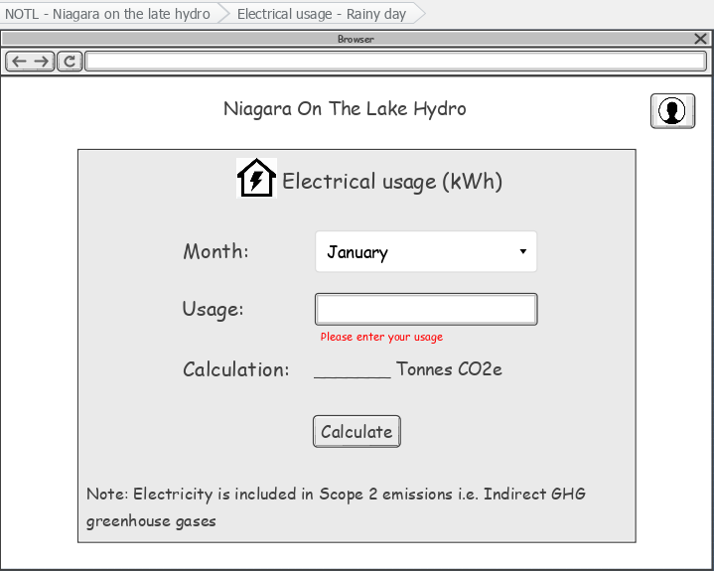

When a customer does not enter any value in usage field then the error message will appear.

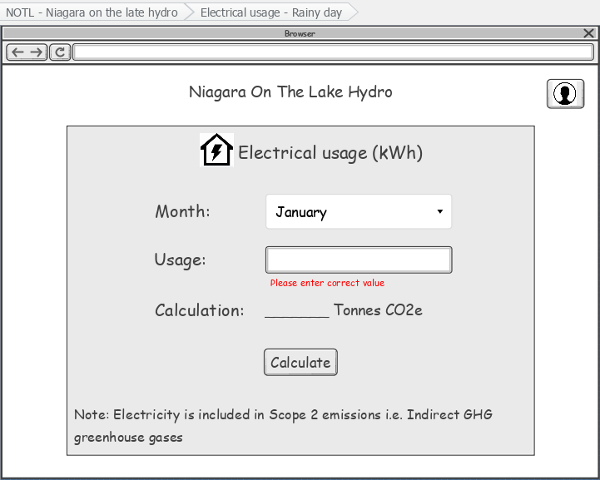

When a customer enters incorrect usage values – negative value, characters, too large value, etc. then the error message will appear.

When a customer enters the wrong values then the Calculate button will be disabled and won’t allow the customer to click on it.

CalculateCarbonfootprints – Fuel Usage – Sunny Day path:

When customer clicks on the Month dropdown, all the months will appear, and the customer can select the month for which they are entering the fuel usage.

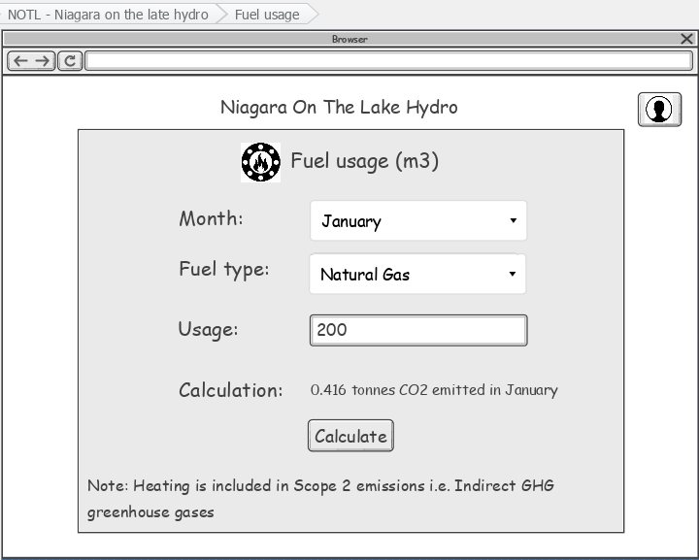

When customer clicks on input field, they will be able to enter the usage in m3.

When ‘Calculate’ button is clicked the calculation result will appear in the above label.

CalculateCarbonfootprints – Fuel Usage – Rainy Day path:

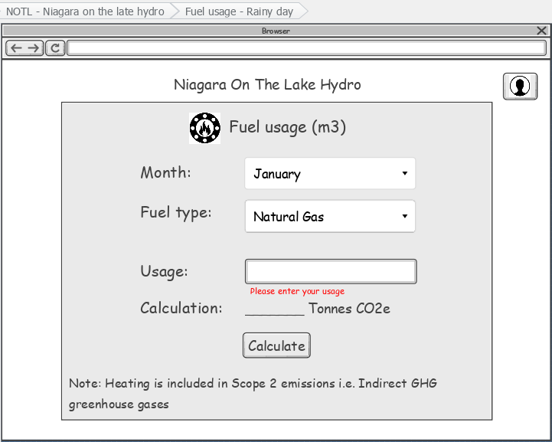

When a customer does not enter any value in usage field then the error message will appear.

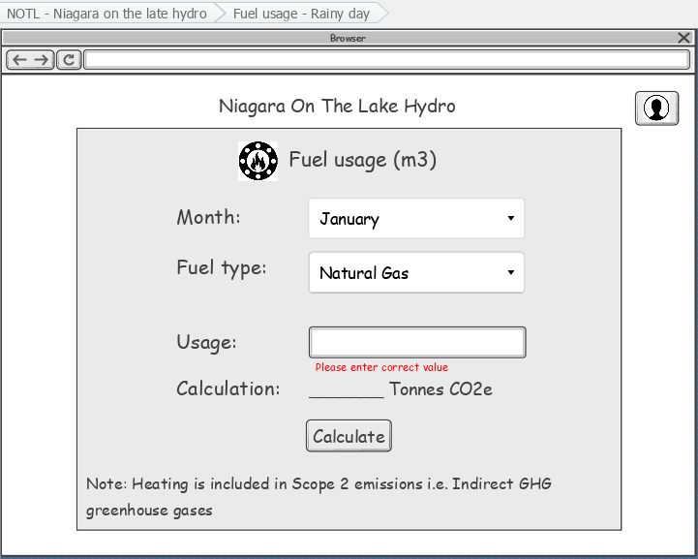

When a customer enters incorrect usage values – negative value, characters, too large value, etc. then the error message will appear.

When a customer enters the wrong values then the Calculate button will be disabled and won’t allow the customer to click on it.

CalculateCarbonfootprints – Water Usage – Sunny Day path:

When customer clicks on the Month dropdown, all the months will appear, and the customer can select the month for which they are entering the water usage.

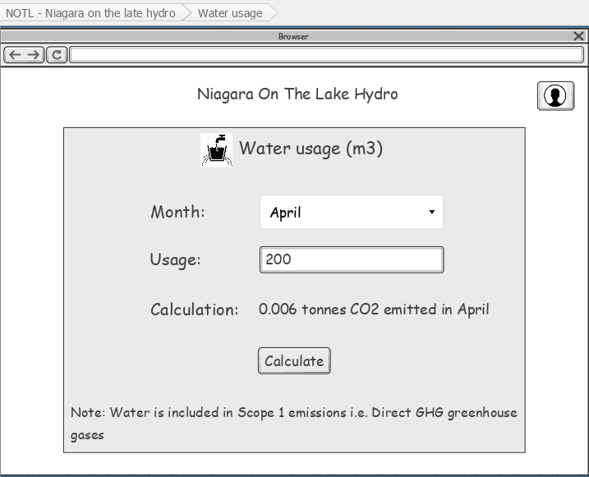

When customer clicks on input field, they will be able to enter the usage in m3.

When ‘Calculate’ button is clicked the calculation result will appear in the above label.

CalculateCarbonfootprints – Water Usage – Rainy Day path:

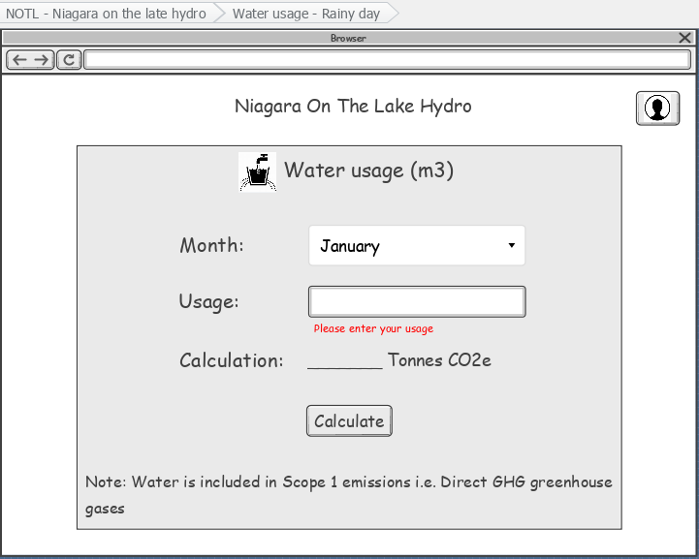

When a customer does not enter any value in usage field then the error message will appear.

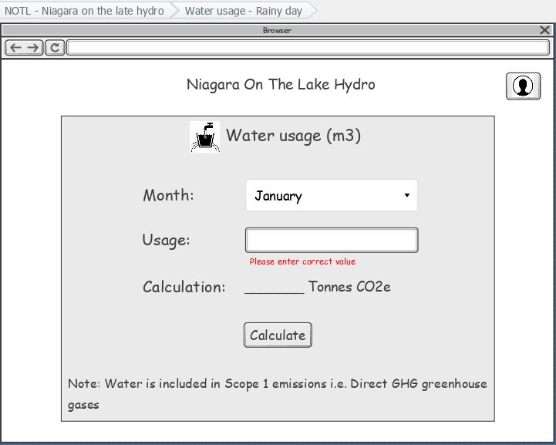

When a customer enters incorrect usage values – negative value, characters, too large value, etc. then the error message will appear.

When a customer enters the wrong values then the Calculate button will be disabled and won’t allow the customer to click on it.

CalculateCarbonfootprints – Vehicle Usage – Sunny Day path:

When customer clicks on the Month dropdown, all the months will appear, and the customer can select the month for which they are entering the vehicle usage.

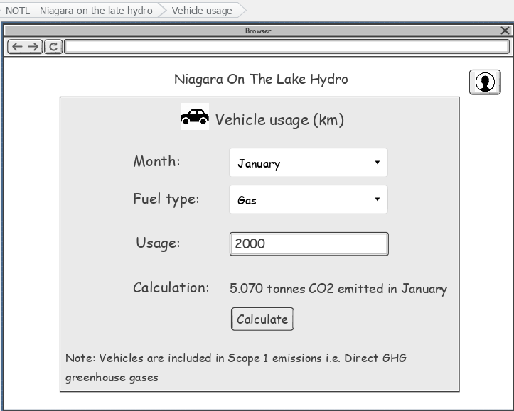

When customer clicks on input field, they will be able to enter the usage in km.

When ‘Calculate’ button is clicked the calculation result will appear in the above label.

CalculateCarbonfootprints – Vehicle Usage – Sunny Day path:

When customer clicks on the Month dropdown, all the months will appear, and the customer can select the month for which they are entering the vehicle usage.

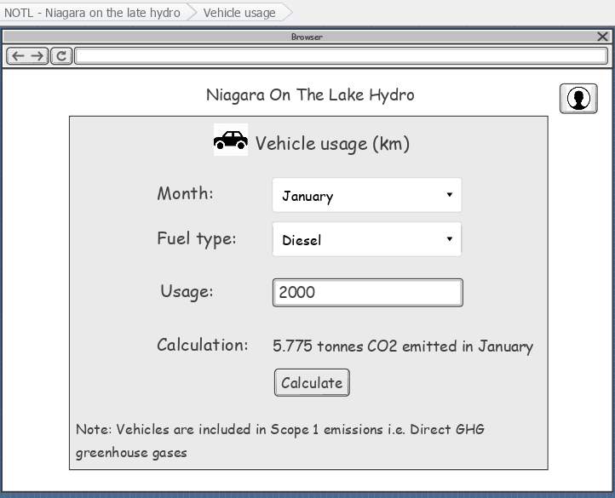

When customer clicks on input field, they will be able to enter the usage in km.

When ‘Calculate’ button is clicked the calculation result will appear in the above label.

CalculateCarbonfootprints – Vehicle Usage – Rainy Day path:

When a customer does not enter any value in usage field then the error message will appear.

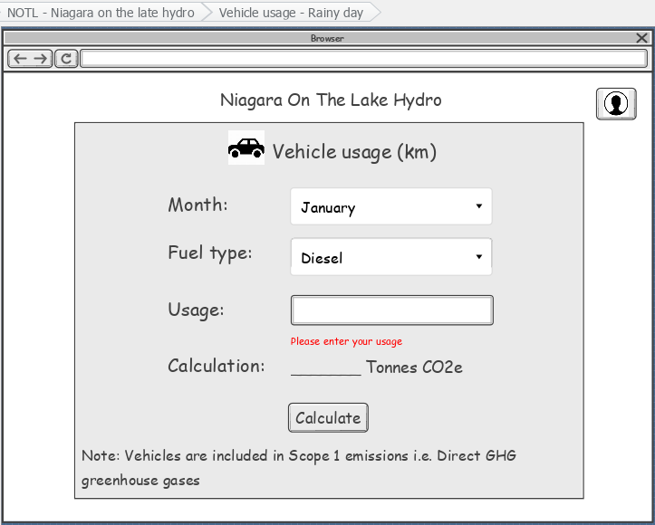

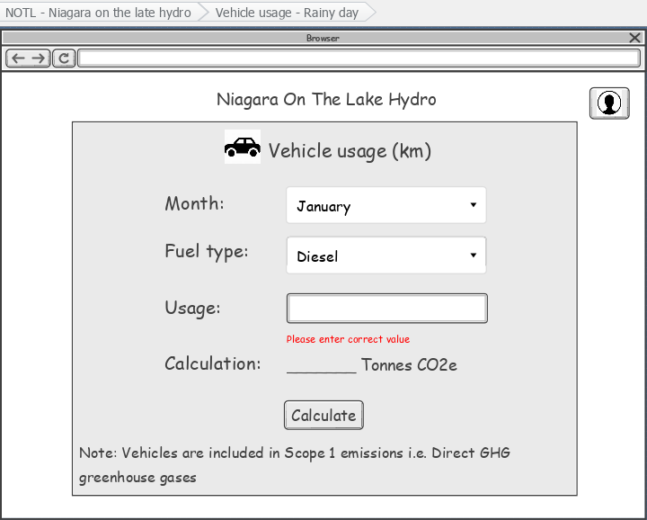

When a customer enters incorrect usage values – negative value, characters, too large value, etc. then the error message will appear.

When a customer enters the wrong values then the Calculate button will be disabled and won’t allow the customer to click on it.

CalculateCarbonfootprints – Flights Usage – Sunny Day path:

When customer clicks on the Month dropdown, all the months will appear, and the customer can select the month for which they are entering the flights usage.

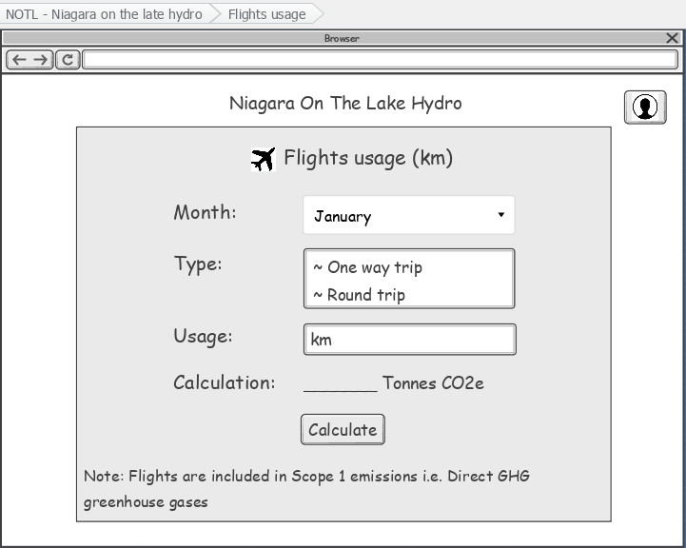

When customer clicks on input field, they will be able to enter the usage in km.

When ‘Calculate’ button is clicked the calculation result will appear in the above label.

CalculateCarbonfootprints – Flights Usage – Rainy Day path:

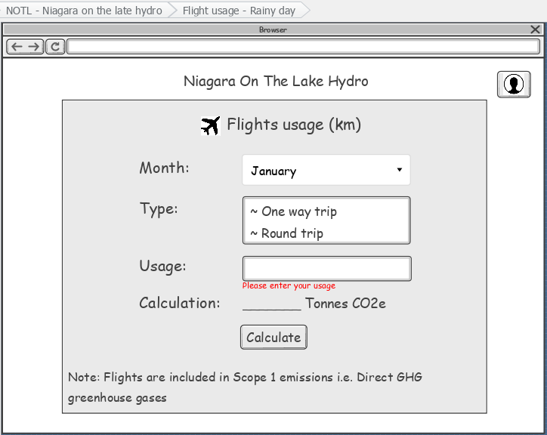

When a customer does not enter any value in usage field then the error message will appear.

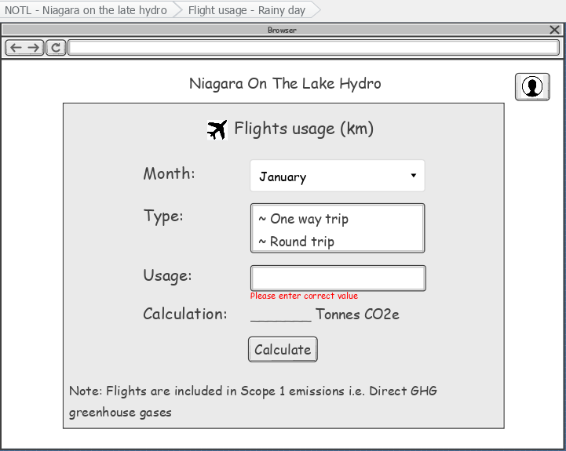

When a customer enters the wrong values then the Calculate button will be disabled and won’t allow the customer to click on it.

When a customer enters incorrect usage values – negative value, characters, too large value, etc. then the error message will appear.

# **Sprint 4:**

## **Use Case Description:**

* ‘ViewCarbonFootPrints is for letting the customers view their carbon footprints history.
* A customer can track their carbon emissions based on their electrical, water, different types of fuel usage monthly. So, if the customer wishes to compare their emissions per month, they can view it in the history page.
* Also, the ‘ViewCarbonFootPrints is related to ‘CalculateCarbonfootprint’ use case as the customer will be able to view the footprint history after calculating their carbon footprints.

## **Model Class Diagram:**

Basic Flow of our website

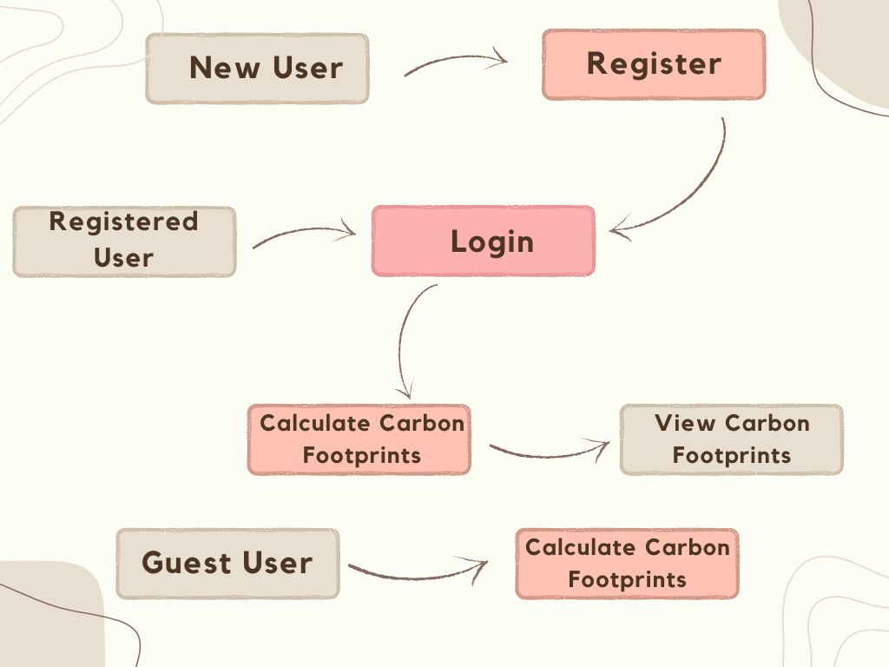

Frontend – Register & Login

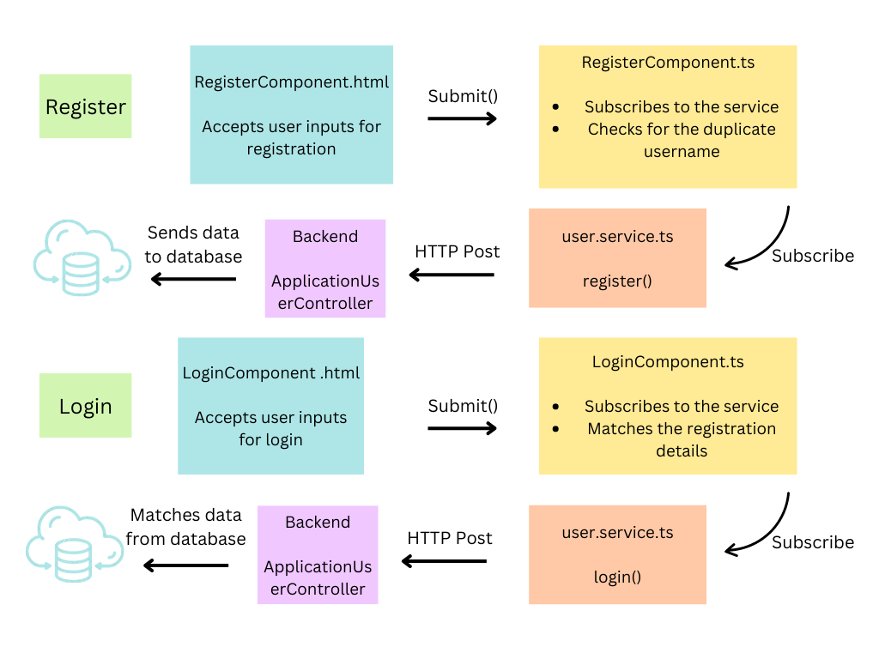

Frontend - CalculateCarbonfootprints

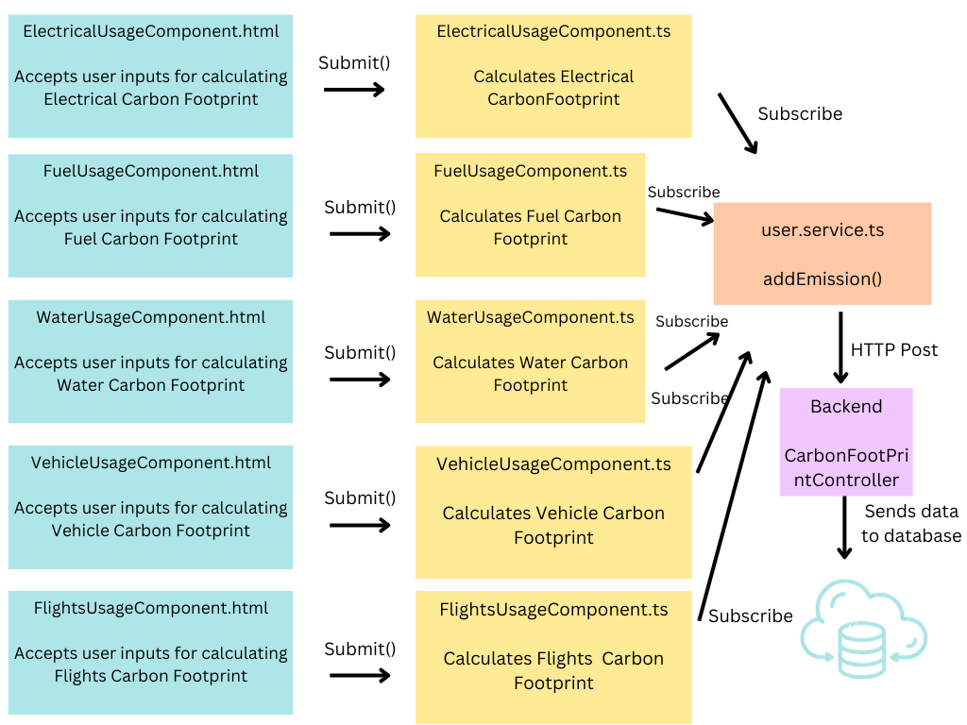

Frontend - ViewCarbonFootPrints

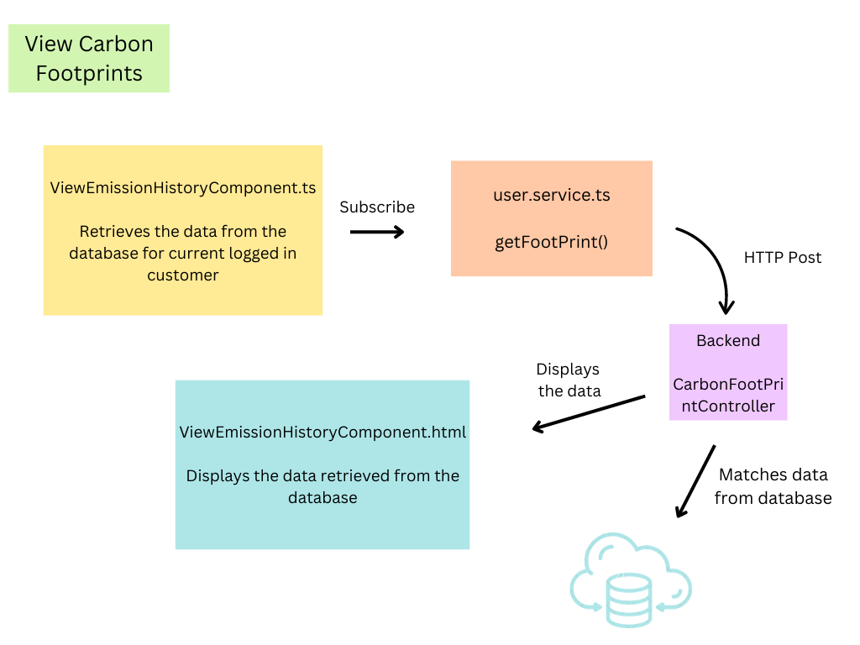

Backend

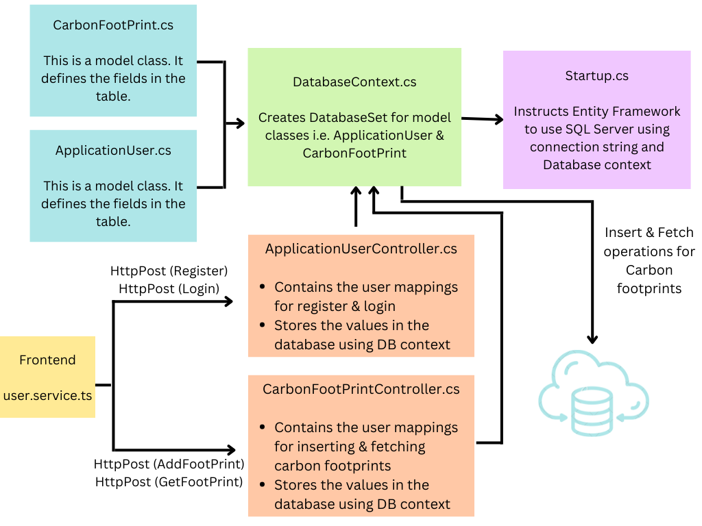

## **Use Case Narrative with Low-Res Wireframes:**

Home Page

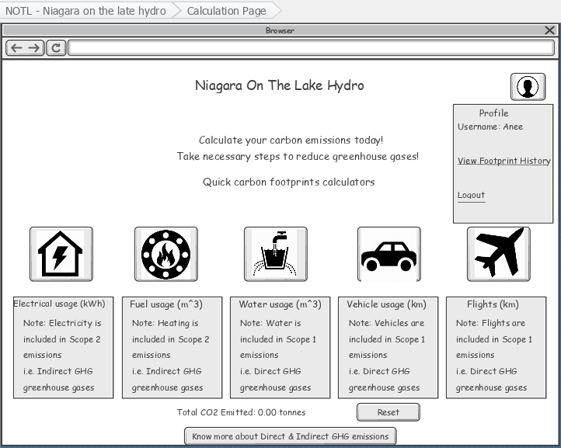

View Carbonfootprints History Page

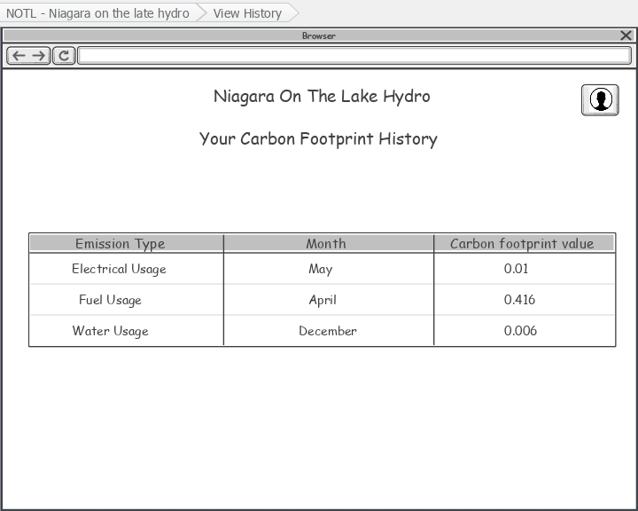

## **Quality Assurance Testing:**

Unit Tests:

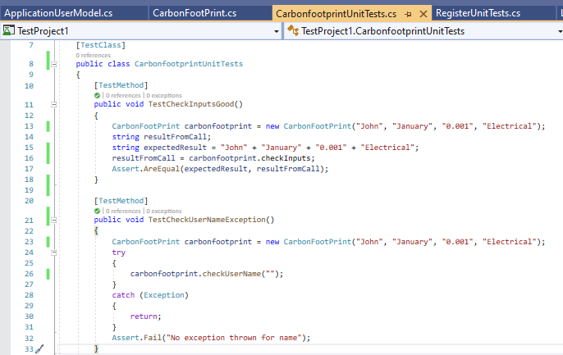

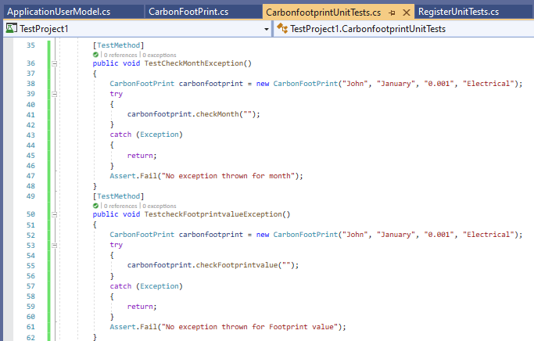

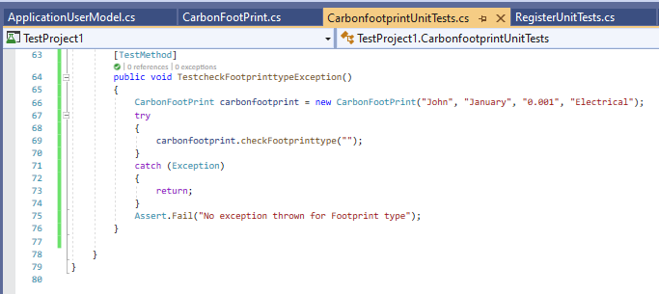

Test Results:

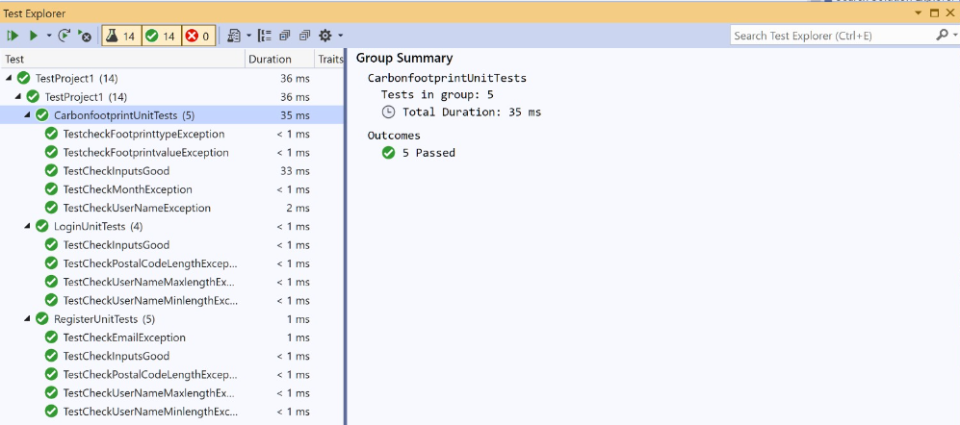

API Tests using Postman

For Register

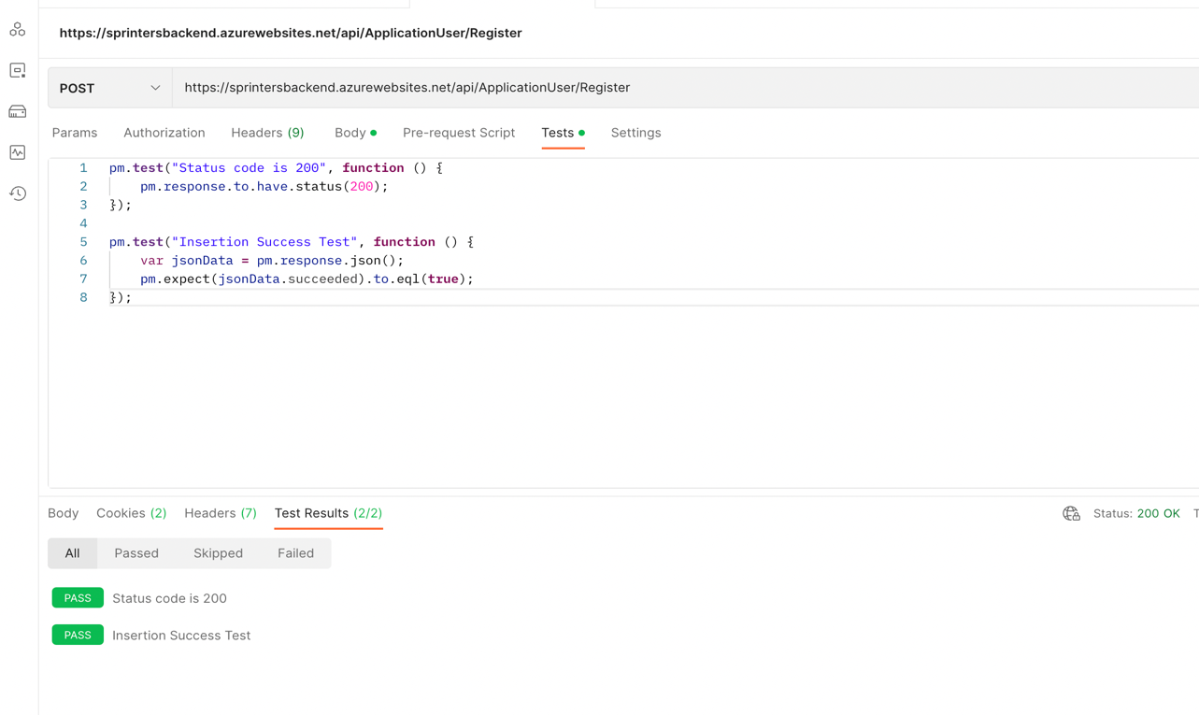

For Login

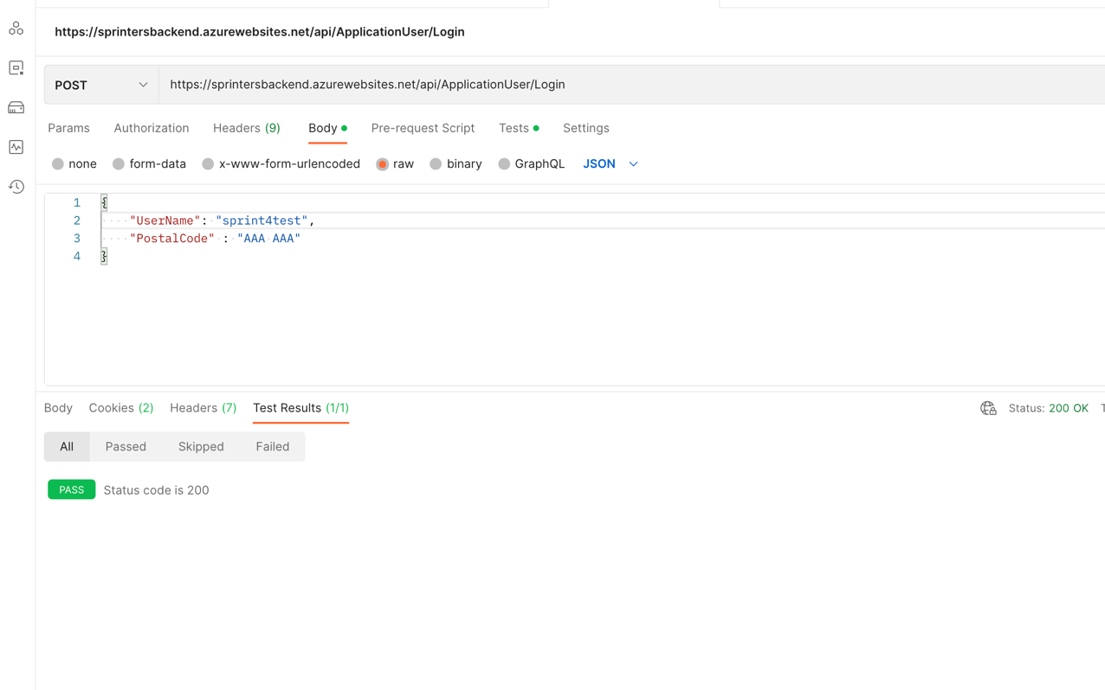

AddFootPrint Test:

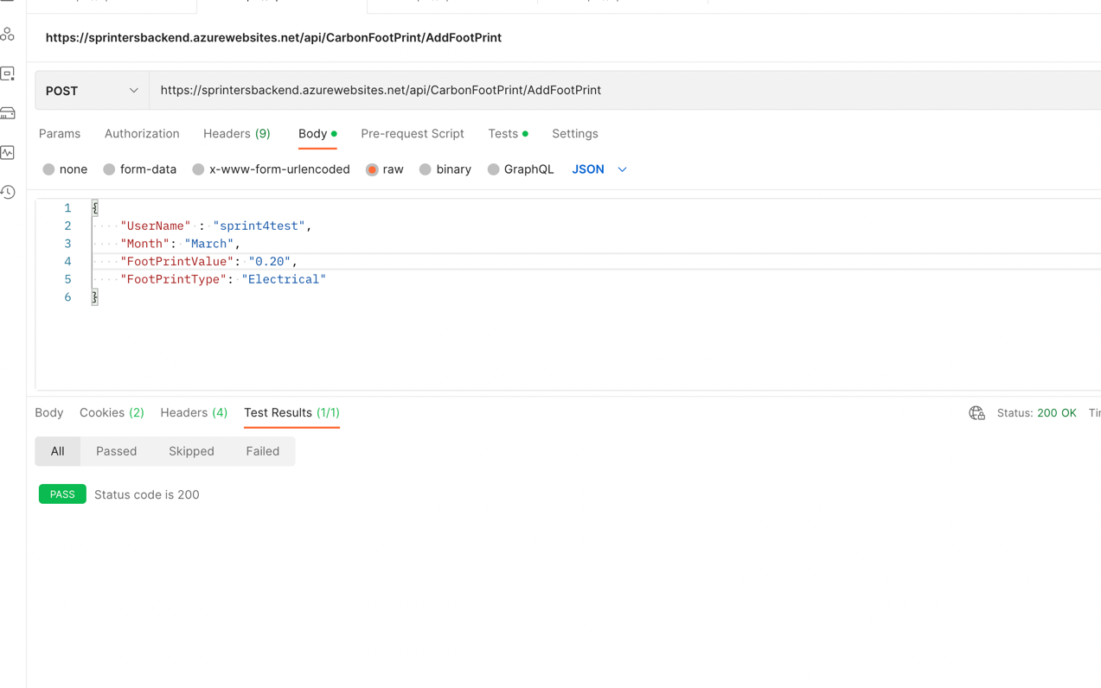

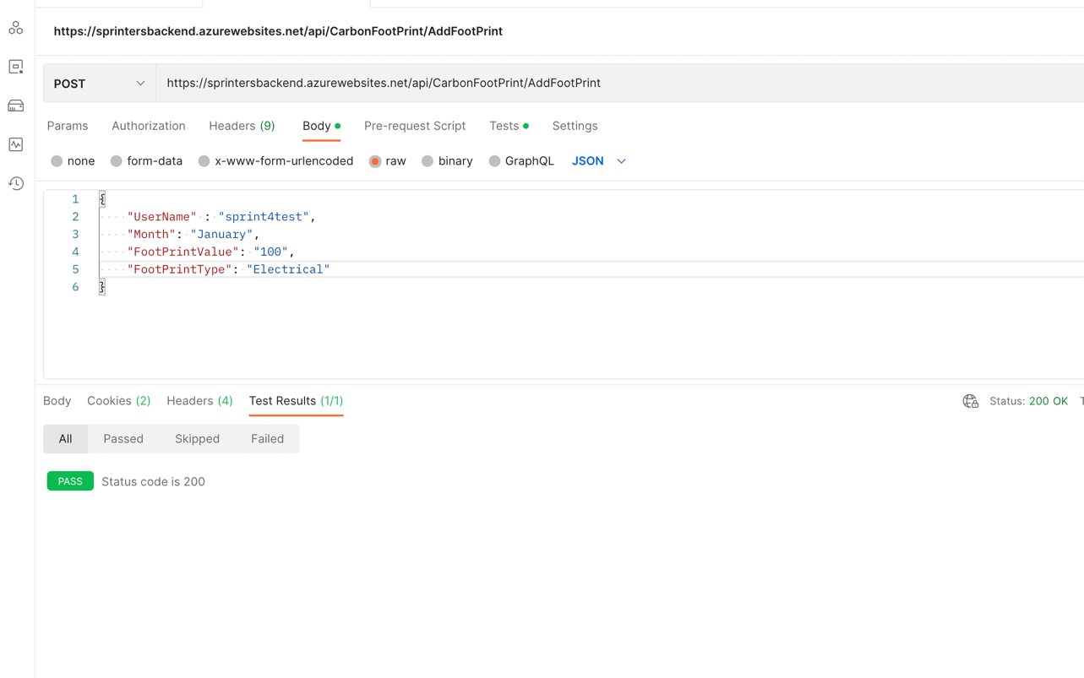

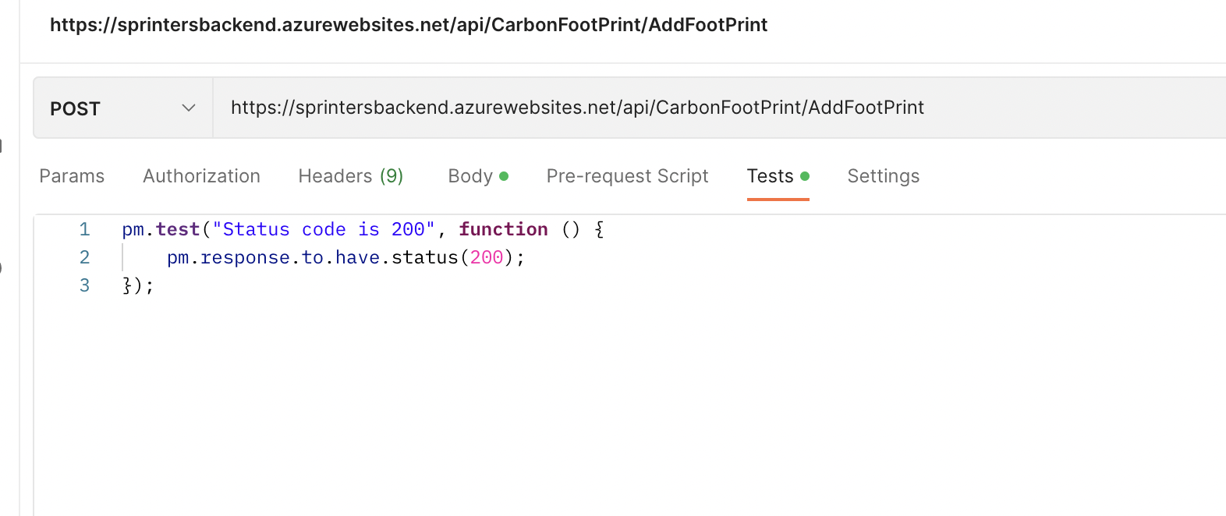

Good Test for GetFootPrint:

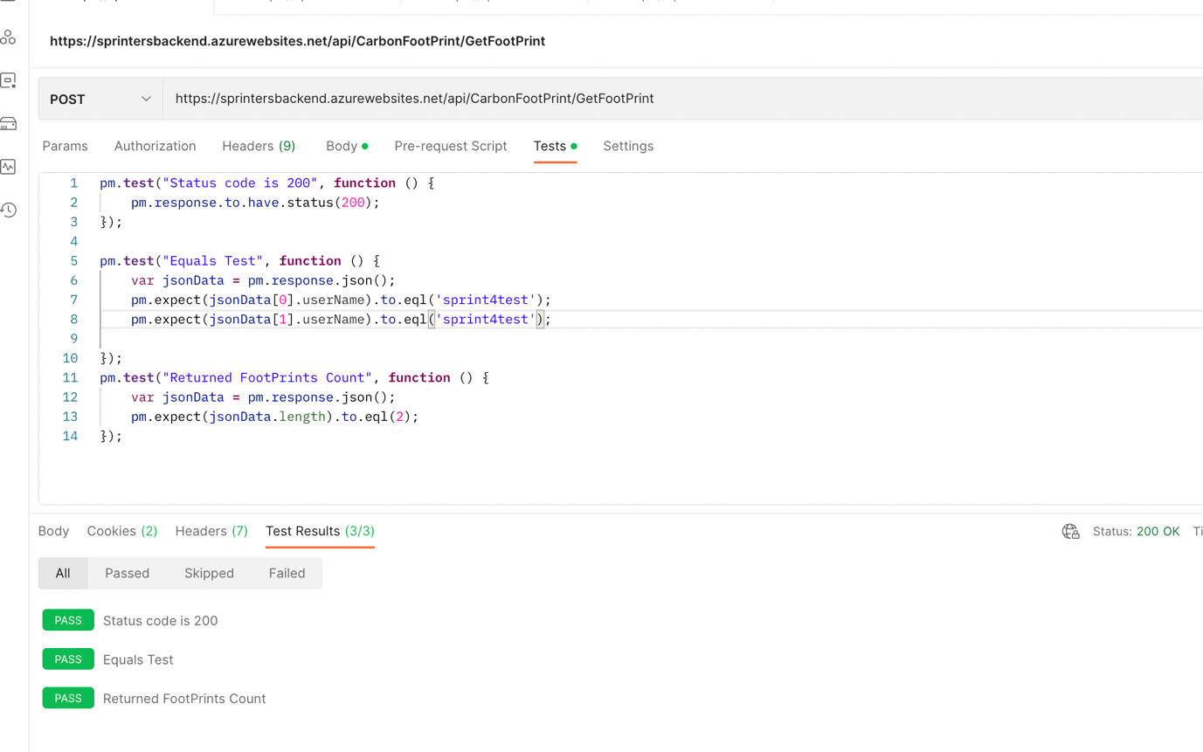

Bad Test for GetFootPrint:

Verifying the fetched footprint belonged to the current user.

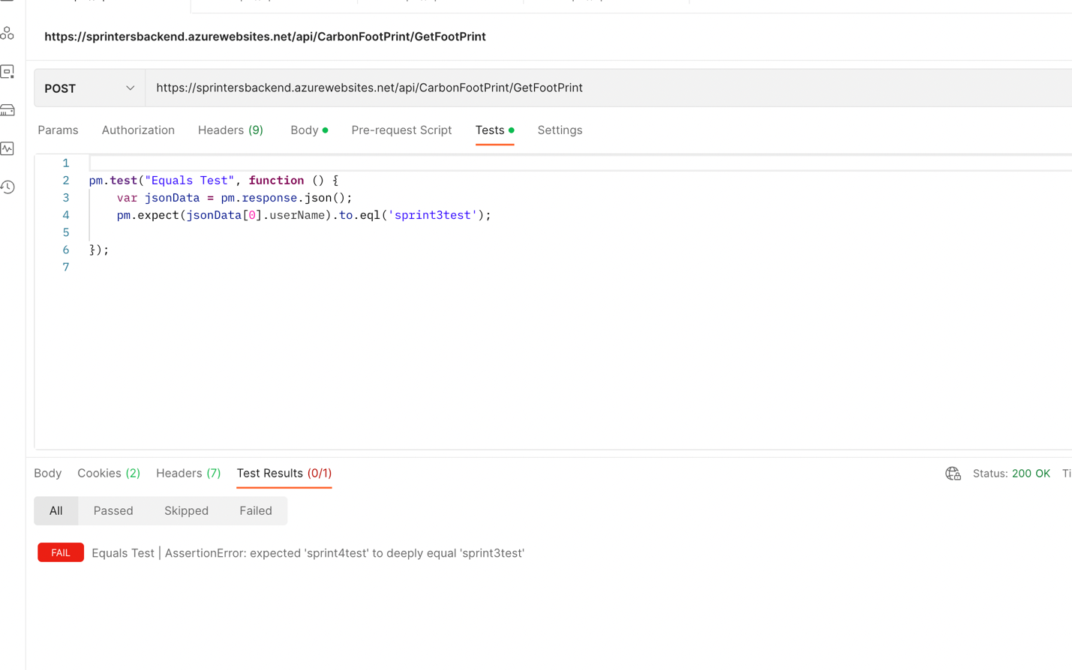

# **Sprint 5:**

## **Use Case Description:**

* ‘SortCarbonFootPrints’ is for allowing the customers to view sorted data on the history page.
* ‘ViewMonthlyCarbonFootPrints’ to allow them to track it according to the months.
* Help resource for the guidance.
* Emission category is for allowing the customers to know what category their total carbon emissions fall in – high, medium, low. This will allow them to decide whether to take actions to lower their emissions or not.
* Number of trees to offset carbon emissions

## **Model Class Diagram:**

Basic Flow of our website



Frontend – Register & Login

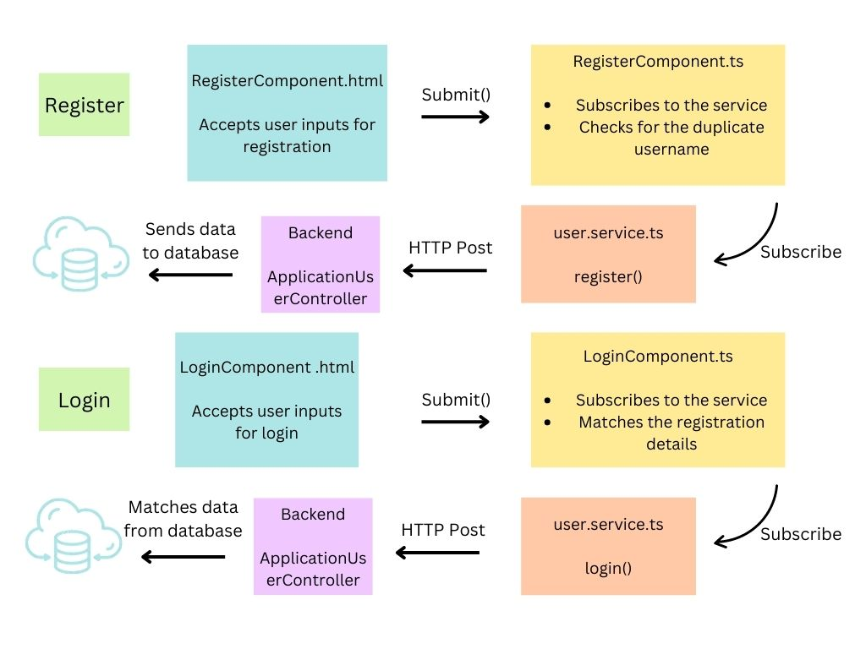

Frontend – CalculateCarbonfootprints

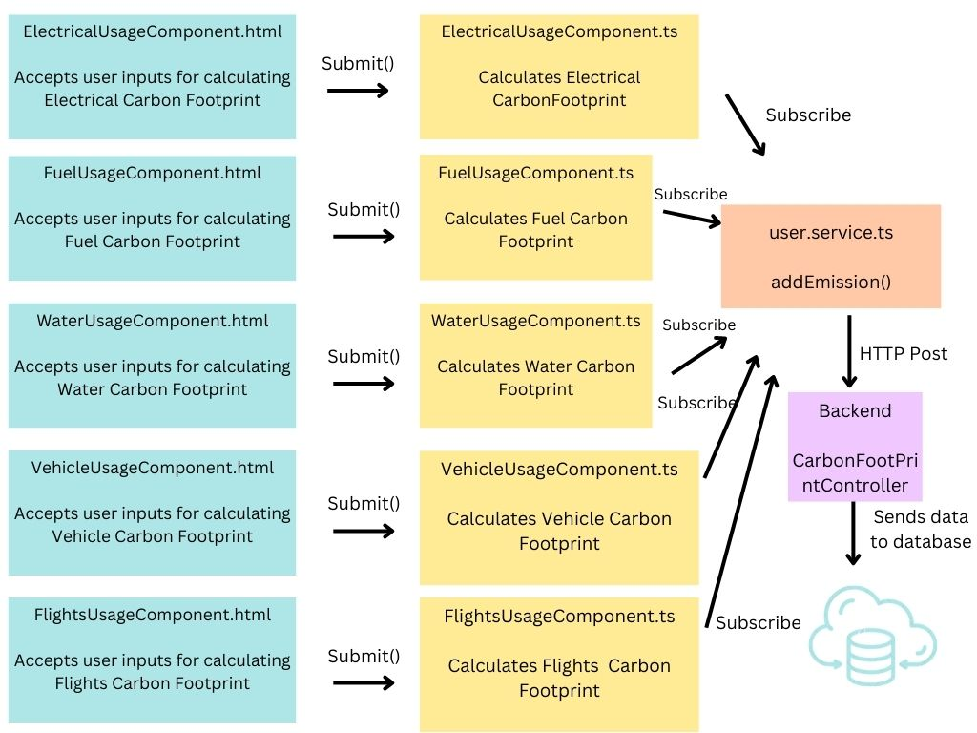

Frontend – Calculators and Home page

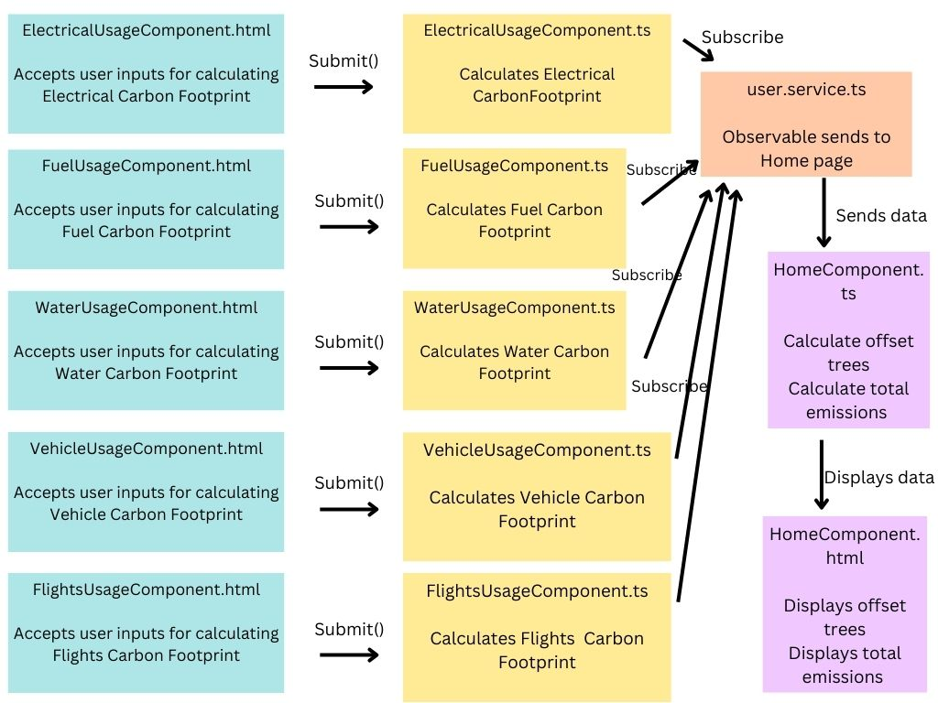

Frontend – ViewCarbonFootPrints

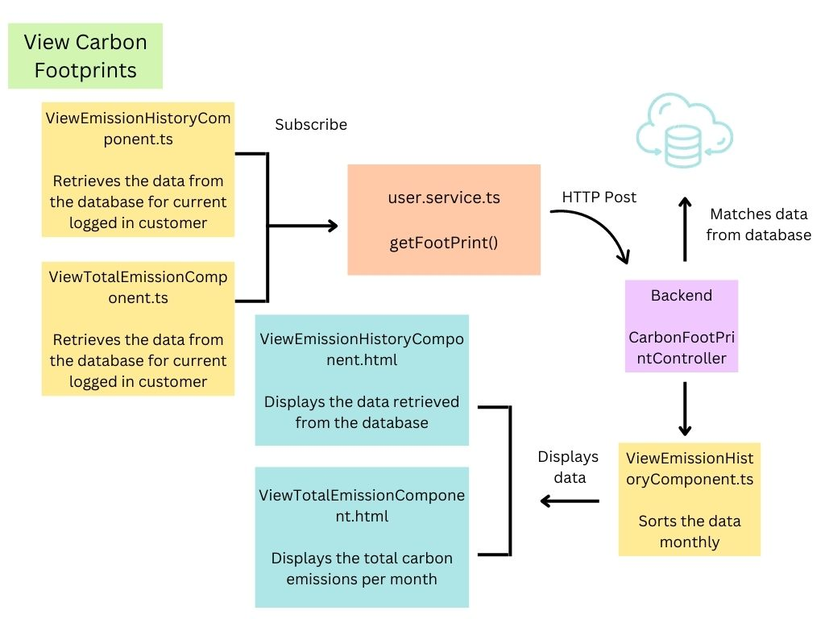

Backend

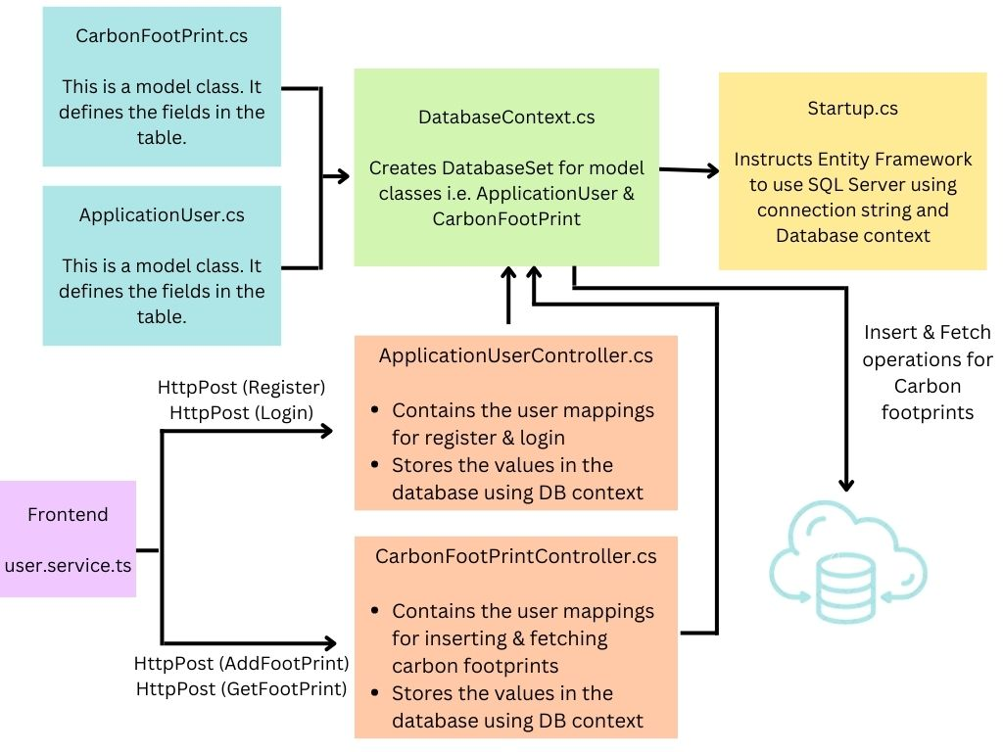

## **Use Case Narrative with Low-Res Wireframes:**

Home Page

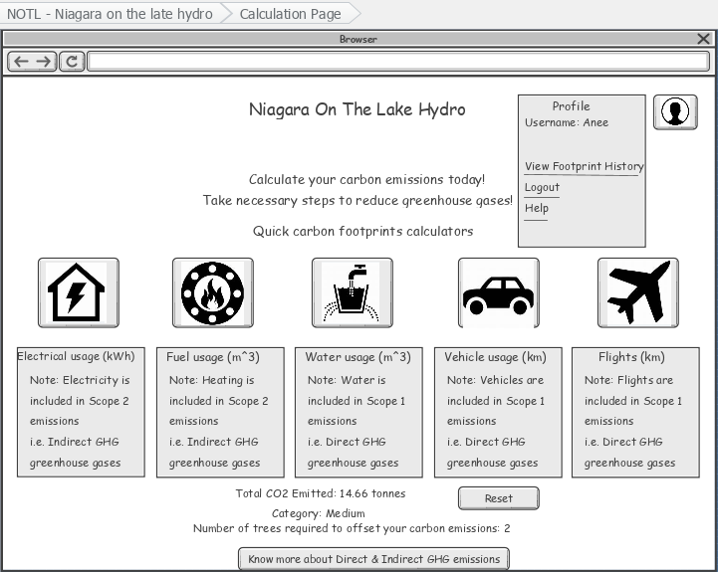

View History

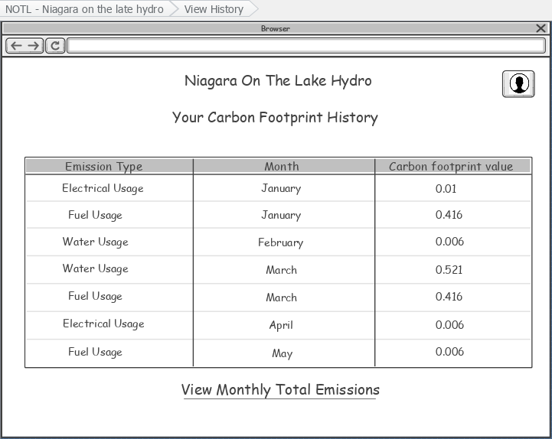

View Monthly Emissions

